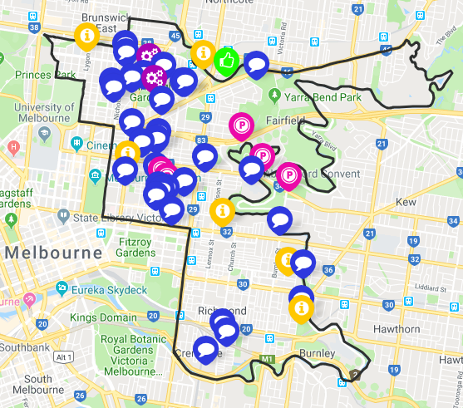

**SUMMARY OF STAGE 1 CONSULTATION: October – November 2018**

Stage1 Consultation: Online survey and in-person discussion opportunities including 3 library sessions

Promotion

* Direct email
* Article in *Yarra Life* eNewsletter
* Promoted on social media
* Promotional postcards

Feedback

* Approximately 80 responses/ submissions/ in person sessions
* All suburbs represented
* All 4 Key directions represented

