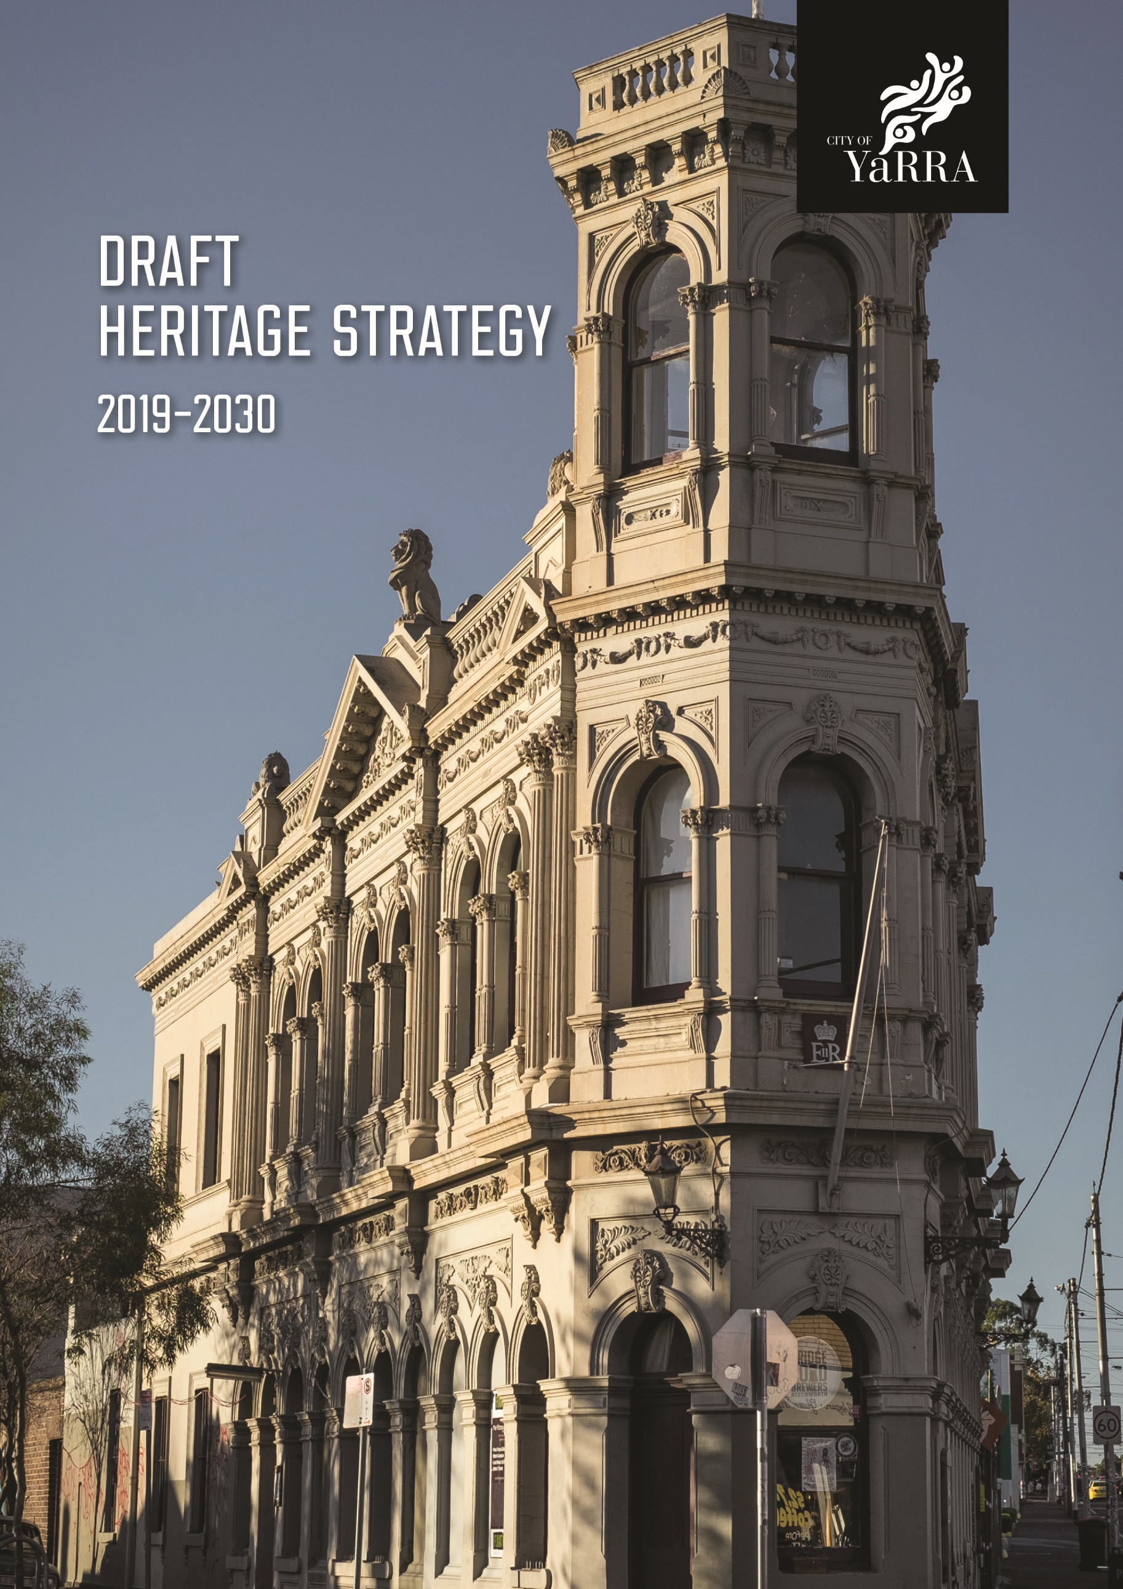

ACKNOWLEDGEMENTS

City of Councillors and Staff
City of Yarra Heritage Advisory Committee City of Yarra Community
Extent Heritage Pty.Ltd.
Yarra City Council acknowledges the Wurundjeri as the Traditional Owners of this country pays tribute to all Aboriginal and Torres Strait Islander people in Yarra and gives respect to Elders past, present and emerging.”

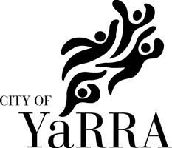
Contents
Introduction 1
Purpose 1
Scope 1
Process 2
Timeframe 2
Context 3
The Historical Context 3
The Legislative and Policy Context 4
Strategic Context 5
Achievements to Date 6
Key Community Concerns and Directions 7
Challenges and Opportunities 7
The Strategy 11
Vision and Direction 11
Strategic Priorities 11
Implementation Framework 13
Business as Usual 14
Implementation Plan 15
References 24
Legislations, Regulations and Policies 24
Key Heritage Studies, Reviews and Amendments 27

Abbreviations and Acronyms CoY City of Yarra
YCC Yarra City Council

HAC Heritage Advisory Committee

ESD Ecologically Sustainable Development

CMP Construction Management Plan

Introduction

The City of Yarra (CoY) has a vibrant and multi-faceted heritage, shaped by its rich history and diverse community. The Wurundjeri people are the Traditional Owners of the land on which the CoY is situated. Today evidence of the various layers of the City’s natural, cultural and urban history can be experienced throughout the municipality.

Yarra City Council (YCC) fully appreciates the importance of its role in the management of the City’s significant heritage, and it is committed to work with the wider community to conserve and enhance this heritage while embracing positive change in the municipality.

Purpose
The City of Yarra Heritage Strategy (‘the Strategy’) is a key document that defines YCC’s strategic approach to the management of heritage. It defines key priorities that are important for developing and promoting a greater understanding of heritage within the community and recommends key actions and measures intended to achieve better protection and management of the City’s heritage places and assets.

Scope
The Strategy builds on the previous Strategy (2015-2019) that set out the responsibilities of YCC in identifying, assessing, documenting and protecting its cultural heritage, both pre- settlement and post-settlement. The scope of the new Strategy has been broadened to include the natural heritage of the municipality, mirroring the holistic approach to heritage adopted nationally and internationally.

The Strategy is applicable to all elements of heritage, from tangible features such as historical buildings and precincts, landscapes, streetscapes, archaeological sites, objects, collections and records, to intangible elements such as cultural practices, stories, traditions, folklore and other knowledge that is inherited over generations. The Strategy focuses on those aspects of the City’s cultural and natural heritage for which YCC has direct responsibility or the opportunity to positively influence.

The actions developed to fulfil this responsibility respond to four key Strategic Directions in accordance with Heritage Victoria’s Municipal Heritage Strategies Guide for Councils. These are:

- Knowing our heritage;

- Protecting our heritage;

- Supporting our heritage, and;

- Promoting and Celebrating our Heritage

A number of departments at YCC are involved in the management of heritage in the CoY. The Strategy recognises that actions that are ‘business as usual’ will be continued by various departments. Therefore this Strategy focuses only on the strategic actions that are important for proactively improving the management of heritage in CoY in the coming years and sets out an action plan that is both achievable and accountable over the life of the new Strategy. The strategy also identifies that the implementation of some heritage outcomes requires support from key external organisations and service authorities

Process
Development of the Strategy followed a consultative process in which YCC’s Heritage Advisory Committee (HAC) has played an instrumental role. A subgroup from the HAC guided the structure and focus throughout the drafting process, and YCC also undertook several stages of wider community engagement. Internal departments responsible for different aspects of heritage management have provided input at different stages in the development of the Strategy to ensure that the implementation actions are achievable and so that they can be embedded in YCC’s core business.

The development of the Yarra Heritage Strategy 2019-2030 has included the following steps:

- Review of the previous Heritage Strategy 2015-2018 and the implementation plan;

- Understanding the historical, legislative and policy, strategic and community context;

- Meetings with YCC’s Heritage Advisory Committee;

- Liaison with YCC departments;

- Community survey, through YCC’s web platform;

- Meetings and workshop with external stakeholders and interest groups;

- Discussion with YCC Executive; and

- Public Exhibition.

Timeframe
Timely implementation of the previous strategy has been challenging. Understanding the processes, time-frames and resource implications of the proposed actions this strategy adopts a 10 year implementation time frame with a proposal for the periodic review of the implementation plan after every four years.

Context

The CoY was formed following the 1994 amalgamation of the former cities of Collingwood, Fitzroy, Richmond, and parts of Northcote and Melbourne. It now incorporates the suburbs of Abbotsford, Burnley, Clifton Hill, Collingwood, Cremorne, Fitzroy, North Carlton, North Fitzroy, Princes Hill and Richmond, together with parts of Alphington and Fairfield. Areas of the municipality have been important gathering places for Aboriginal people for thousands of years. The CoY is bound by the Yarra River (traditionally known as ‘Birrarung’) on three sides. The river corridor has significant natural and cultural heritage values, especially for the region’s Wurundjeri Traditional Owners.

The Historical Context
The Wurundjeri people of the Kulin Nation are the Traditional Owners of the place that we know today as the City of Yarra. Their relationship with the City extends back tens of thousands of years to when their creator spirit ‘Bunjil’ formed their people, the land and all living things. The Birrarung is a rich natural and now managed landscape that was and remains integral to Aboriginal people’s sense of place. This is also true of other watercourses in the municipality, including the Merri Creek in particular.

Archaeological evidence of Aboriginal occupation can be found throughout the municipality, especially along its watercourses, together with scar trees. The banks of the Yarra River, once intensively used for industry, are now also highly valued green spaces for leisure and recreation.

The suburbs that are now part of the CoY initially developed from 1839 as residential areas to house the Colony’s growing population. The establishment of industries along the Yarra River provided employment for the new arrivals in a period of rapid population growth. Industrial and commercial life grew and centralised around the early locales of Fitzroy, Collingwood, Abbotsford and Richmond.

The CoY includes some of Melbourne’s earliest established suburbs, whose history remains evident in the significant nineteenth and early twentieth century architecture, subdivision pattern, street furniture, parklands, trees and other elements. Rows of cohesive streetscapes with single storey workers cottages and double storey terraces exist with middle class villas and landmark civic and religious buildings. The layout of the suburbs of Fitzroy, Richmond and Princes Hill is largely mid Victorian in design. However, the evidence of slum clearance in the form of 1960s–70s tower developments has dramatically changed the physical form of some of these areas. Abbotsford, Collingwood and parts of Richmond and Fitzroy developed largely as manufacturing areas with industry and residential development existing side by side. Following the Second World War, rapid growth and population change have brought diversity and physical transformation to the suburbs of Yarra.

The CoY also has a number of late Victorian and Edwardian shopping strips that exhibit consistent streetscapes of heritage facades and shop fronts. These centres contribute to the economic prosperity of the CoY. The population boom of the last two decades has added enormous pressure for redevelopment of underutilised ex-industrial and large sites, especially

in and around the shopping strips, and this has started to impact the character and feel of these places.

The municipal history of the CoY is reflected in its notable public and civic buildings, such as the Fitzroy Town Hall (1874), Collingwood Town Hall (1887) and Richmond Town Hall (1890). The Royal Exhibition Building and Carlton Gardens (located immediately adjacent to the CoY) witnessed the opening of the first Australian Parliament in 1901, as well as the great exhibitions of 1880 and 1888. It is important that the heritage of these places is celebrated and conserved.

The Legislative and Policy Context
Heritage places in Australia are protected by Federal, State and Local Government legislation or regulations. A list of the relevant legislation is attached in the reference section at the end of this report. The management requirements for such places depend on the level of their recognised heritage significance.

Local Government plays an important role in heritage conservation; from its identification and appropriate statutory protection, to the management of change in the urban environment and celebration of its diverse heritage. The Yarra Planning Scheme includes the vision and strategic directions for future planning and development of the municipality which are brought into effect through a number of planning provisions and the requirements of local planning policies (such as for built environment and heritage), zones and overlays such as Heritage Overlay, Design and Development overlay etc.

The Victorian Government has the main responsibility for managing and legislating for the protection and listing of State and Locally significant heritage. It also provides oversight and education through its relevant heritage agencies; Heritage Victoria and Aboriginal Victoria, and other agencies such as Parks Victoria are concerned with both the natural and cultural heritage of the State.

As independent statutory bodies, the Victorian Heritage Council and Aboriginal Heritage Council are respectively responsible for the Victorian Heritage Register (VHR) – that recognises places of state level heritage significance – and the Victorian Aboriginal Heritage Register (VAHR). The Commonwealth Government also has a responsibility for cultural and natural heritage through the National Heritage List and the World Heritage List.

Importantly, approximately 70% of properties in the CoY are included in the Heritage Overlay. These places include residential, commercial, industrial and civic buildings and are mostly located in one of the 54 heritage precincts in the CoY. The Heritage Overlay also applies to a number of parks and landscapes within the municipality. A substantial number of places are included in the Victorian Heritage Register by virtue of their State-level heritage significance. Abbotsford Convent is a significant asset in Yarra that has been recently included in the National Heritage List, while the UNESCO World Heritage listed Royal Exhibition Building and Carlton Gardens are located just outside the municipal boundary, with parts of Fitzroy in the south western corner of the municipality included in the World Heritage Environs Area buffer zone.

The State Government introduced the Yarra River Protection (Wilip-gin Birrarung murron) Act in 2017. There is a Yarra River 50 Year Community Vision prepared as a part of its

implementation which has a focus on understanding and respecting the history of the river, celebrating the vital and continued role of the Traditional Owners its custodians and recognising its role in their culture. The State Government is currently preparing a Yarra Strategic Plan with priority actions for the coming years. Once this plan is finalised, actions relating to protecting and commemorating cultural heritage of the river will need to be developed to supplement the action plans in this Strategy, to provide an integrated and collaborative approach to heritage conservation, enhancement and interpretation.

Strategic Context
Plan Melbourne (2017-2050)
Plan Melbourne (2017-2050) is the State Government’s long term planning strategy to manage growth and development in metropolitan Melbourne. While Plan Melbourne advocates for accommodating new housing in activity centres near places that offer good access to jobs, services and public transport, it relies on preserving Melbourne’s uniqueness as one of the key principles for planning for the future, and specifies its heritage as one of the city’s distinctive qualities.

Direction 4.4 of Plan Melbourne undertakes to:

“Respect Melbourne’s Heritage as we build for the future”.

It also includes the following policy goals to help implement this direction:

  - Recognise the value of heritage when managing growth and change

  - Respect and protect Melbourne’s Aboriginal cultural heritage

  - Stimulate economic growth through heritage conservation

  - Protect Melbourne’s heritage through telling its stories.

Council Plan 2017-2021
YCC’s Council Plan 2017-2021 sets out priorities and direction for the Council until 2021, and one of its key objectives is that development and growth are managed to maintain and enhance the character and heritage of the city. This is supported by several strategies, including relating to acknowledging and celebrating Aboriginal history (Strategy 2.3) and supporting and empowering a more sustainable Council and Community (Strategy 3.2). Strategy 4.1 is “Protect Yarra’s heritage and neighbourhood character”, under which a main initiative (4.1.1) is to strengthen the protection of Yarra’s heritage through the planning scheme, education, and resource provision.

Other Strategies of the Council
A number of service areas of YCC include the management of heritage amongst their responsibilities. A list of the various YCC strategies of that relate to heritage is provided in the Reference section.

The Burra Charter
The Australia ICOMOS Charter for the Conservation of Places of Cultural Significance (2013) - the ‘Burra Charter’, and its practice notes provide conservation best-practice guidance and principles to inform decision making. More detailed information on the Burra Charter can be accessed at: https://australia.icomos.org/

As one of the three municipalities in Melbourne’s Inner Metro Region (together with the Cities of Melbourne and Port Phillip) the CoY has been experiencing significant development pressure in activity centres, underutilised industrial sites and mixed use and employment precincts. In this scenario of growth and change it is important that Burra Charter principles of conservation are correctly applied to ensure a clear voice for heritage in planning and management decision making.

Achievements to Date
YCC and the Yarra community have been in the forefront of heritage identification and protection for many years, CoY having been one of the first municipalities in Victoria to systematically study its heritage and protect places of value.

A number of heritage studies have been undertaken in the past covering the entire municipality. The studies have also identified potential future heritage survey work to fill in the gaps. There are excellent local history collections in the CoY libraries, while Yarra’s Arts and Cultural Services unit also maintains arts and objects of heritage significance. YCC has launched a web application (PastPort) to document Yarra’s history and heritage through community participation.

To support the protection and management of CoY’s heritage, the findings of its many heritage studies have been implemented into the planning scheme through the Heritage Overlay, covering buildings, precincts parks and gardens. YCC also has the responsibility to manage and maintain its own heritage buildings. YCC provides ongoing funding to the Victorian Heritage Restoration Fund (Yarra Restoration Fund) to provide financial assistance for restoration works, and also provides ongoing support to local historical societies.

Many departments of YCC are involved in the management of heritage in it many different aspects. A Heritage Advisory Committee (HAC) has been re-established to advise on strategic heritage matters, whilst YCC employs three part-time heritage advisors to provide advice on planning applications and has an in house Senior Advisor City Heritage to advise on significant and strategic heritage matters. At the community level there are many community-based organisations and advocacy groups involved in a broad range of heritage activities.

YCC has initiated an Aboriginal History of Yarra website and the Aboriginal Heritage Walking Trail to further the understanding of the Aboriginal history of the area. Interpretative signage exists for some streets and buildings within the municipality, and the CoY website and Yarra Libraries provide access to YCC’s heritage studies and other relevant heritage information. YCC participates in heritage festivals and Open House Melbourne, and it has recently launched a community heritage awards to recognise and honour community members (individuals or groups) for their contribution to the protection and enhancement of Yarra’s history and heritage.

Key Community Concerns and Directions
Various consultations in the past few years have indicated that heritage is one of the characteristics of Yarra that is most valued by the community. Local historical societies play an active role in documenting and promoting the history and heritage of Yarra, and there are also other community groups advocating for heritage protection and management.

The community engagement undertaken during the preparation of this Strategy identified a series of main themes that are important to the community for the future management of heritage in Yarra. These are that:

- More control is needed around buildings heights and intensity of new development;
- More focus needs to be placed on social/cultural/arts - stories and creative sharing;
- There is concern around the trend towards facadism – the retention of only the fronts of buildings, with the corresponding loss of other built heritage fabric;
- Graffiti/vandalism is a problem in the municipality that effects its cultural heritage. There are also too many advertising signs in the built environment and impact on the heritage qualities;
- There is a need for more heritage related information and interpretative signage;
- The quality and consistency of information on the heritage of the municipality needs to be improved, as does the community’s access to it;
- Greater provision of heritage advisory services to the community is necessary;
- Aboriginal heritage should be better recognised in the municipality;
- Natural heritage should be better recognised in the municipality;
- There is a need for YCC to strengthen its existing provisions and management framework to improve the overall response to heritage; and
- Alterations to heritage properties to achieve universal access or improved sustainability – in particular through installation of solar panels, are recurring issues for YCC.
A workshop attended by representatives of key community organisations, developers and heritage practitioners identified a key desirable outcome to be increased capacity to manage heritage within YCC, with the concept of a dedicated heritage department/unit receiving significant support.

Challenges and Opportunities
Current challenges and opportunities have been identified based on the discussions with various stakeholders, including internal YCC departments involved in the management of heritage, and the Heritage Advisory Committee. The community concerns and feedback derived from community surveys, and stakeholder workshops have also been taken into consideration. Opportunities and challenges have been identified relative to the Strategy’s Strategic Directions, and these are set out in the table below which provide the basis for the Strategic Priorities, later discussed in the report.

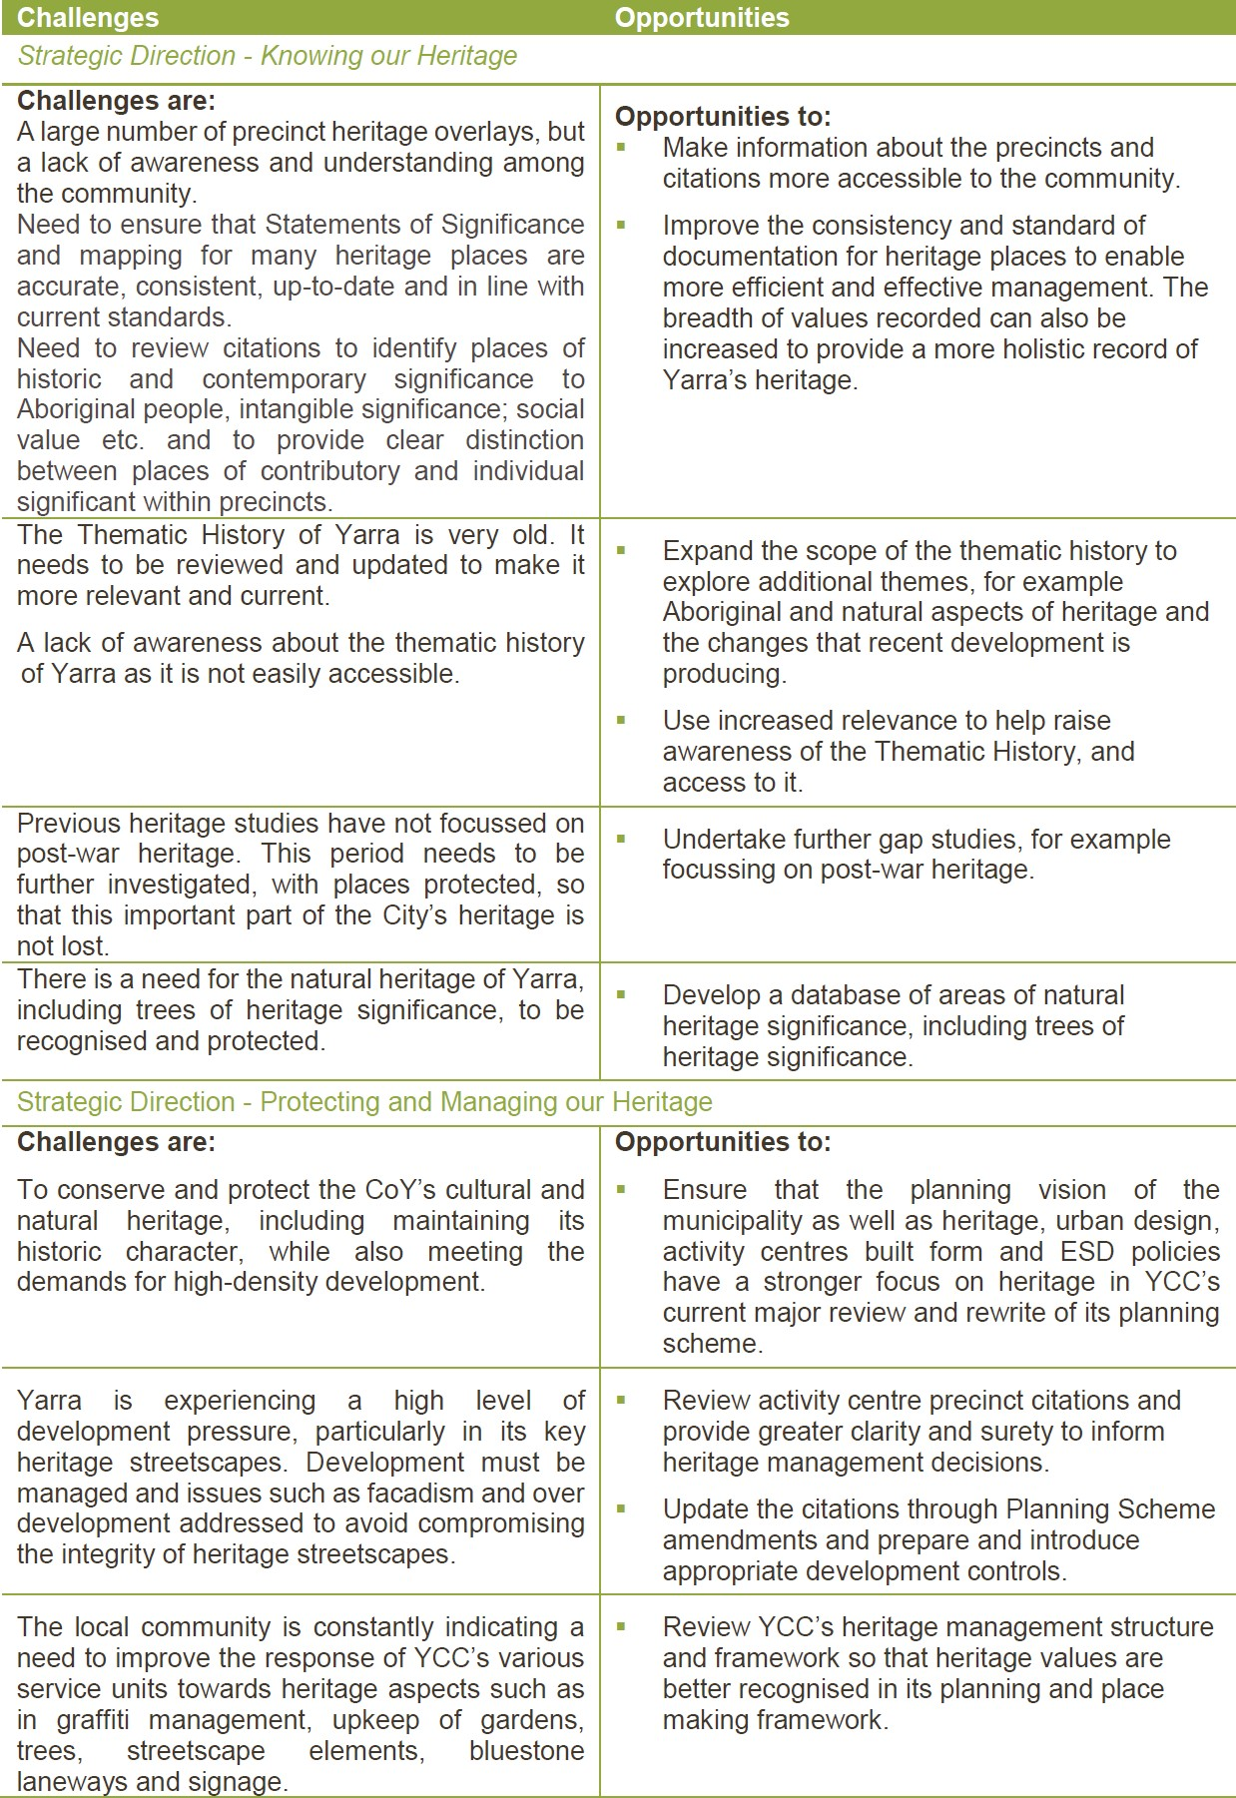

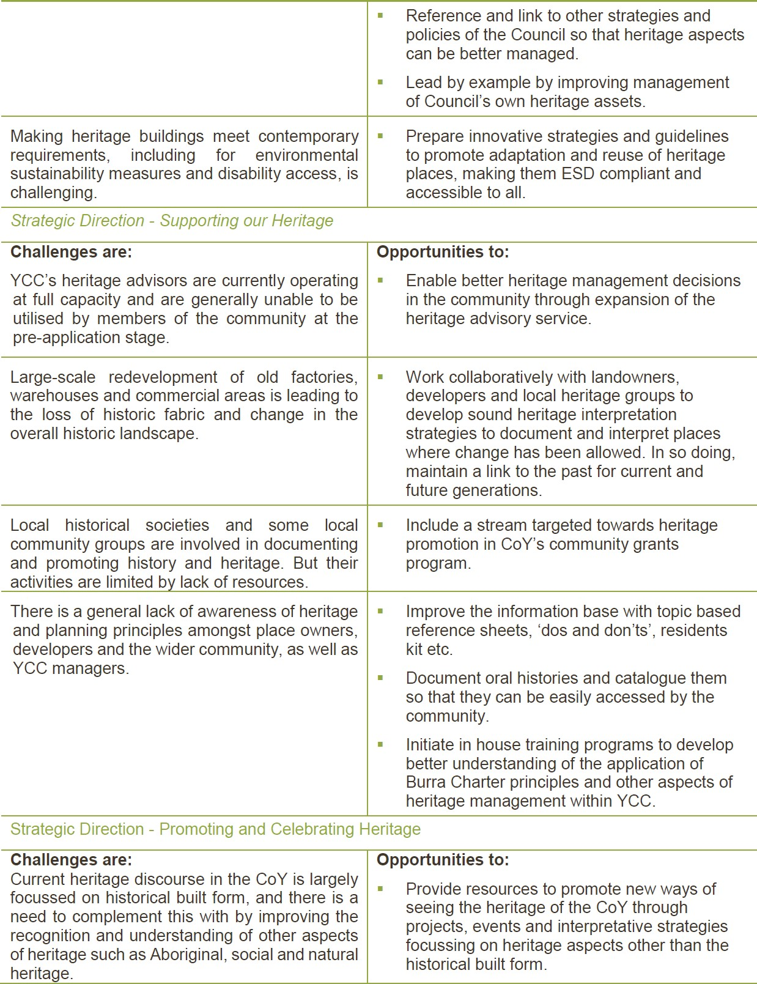

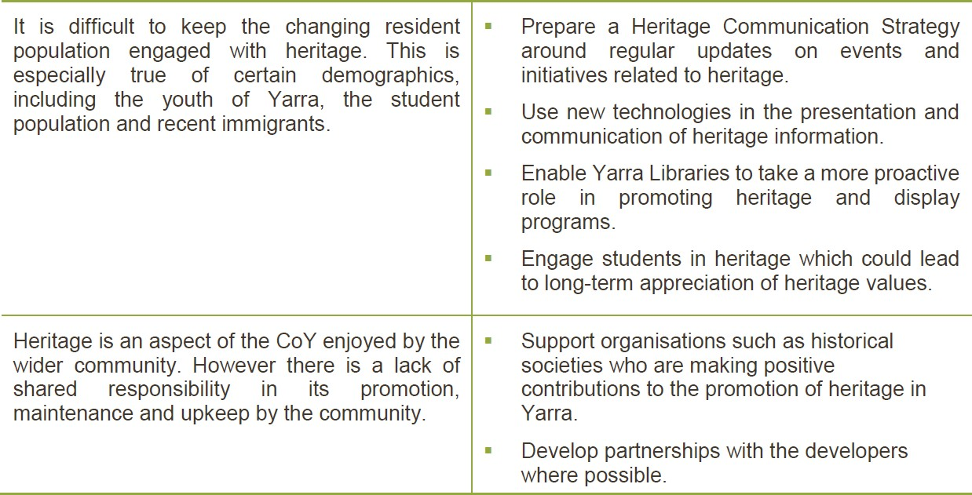

The Strategy
The Strategy recognises the strong presence and high importance of heritage in CoY and provides a long-term vision and practical and achievable direction to improve its management over the next ten years. It will be achieved through an Implementation Framework that supports an implementation plan of priority actions with achievable measures and timeframes.

Vision and Direction
The Council’s vision for heritage in the CoY is as follows:

The City of Yarra is known as a place where our rich natural, Aboriginal, built and other cultural heritage is nurtured, protected and celebrated: It helps to define the city’s identity, support its diverse living culture and is valued by current and future generations.

To achieve this vision the aim of the four Strategic Directions will be:

Knowing our Heritage
To improve our understanding of heritage of Yarra by identifying places that are important to us and ensuring that information about them is comprehensive and publicly accessible.

Protecting and Managing our Heritage
To develop and promote a robust policy and management framework that makes heritage a primary consideration in all elements of planning and place-making. YCC will also lead by example and demonstrate best-practice heritage management of its own properties and assets.

Supporting our Heritage
To support our heritage through a proactive involvement of YCC and the community in the management, care and conservation of our heritage.

Promoting and celebrating our Heritage
To celebrate heritage as a community, enhancing its value for all.

Strategic Priorities
Against the four Strategic Directions, eight ‘Priority Areas’ have been identified that together provide scope to address what are considered the most pressing heritage issues for the municipality.

These Priority Areas are summarised in the following table.

Strategic Direction | Priority Area
Knowing our heritage | - Improved Statements of Significance and Precinct Citations  - Natural Heritage
Protecting and managing our heritage | - Strengthening existing provisions and management framework  - Managing YCC's Own Heritage Assets
Supporting our heritage | - Heritage Advice  - World Heritage
Promoting and Celebrating our heritage | - Aboriginal Heritage  - Heritage Promotion and Community Access to Information

With reference to the full range of activities identified as desirable, but recognising that not everything can be achieved immediately, the above priorities were identified by YCC’s Heritage Advisory Committee and supported through community workshops and meetings with YCC Executives.

The above priority areas identified for the strategic direction inform the action plan. As the Strategy has a 10 year horizon, the activities need to be set within the context of an implementation plan.

Under the Strategic Direction of ‘knowing our heritage’, the need to improve the existing baseline of knowledge to ensure fully informed decision making has drawn attention to the need for improved Statements of Significance and Precinct Citations, whilst the inclusion of natural heritage in the new Strategy prompts the need to understand this aspect of heritage in the municipality better.

Under ‘protecting and managing our heritage’, improving mechanisms for heritage management requires first that areas that are currently in operation be functioning at an optimal level. Hence the focus should be on strengthening existing provisions, and on improving the management framework, with a single unit of department having oversight. YCC also seeks to set a good example in Yarra by ensuring that the management of its own heritage assets is effective and in line with best practice.

The Strategic Direction of ‘supporting our heritage’ is directly served by a focus on improving and expanding access to YCC’s heritage advice services, to enable the wider community to

undertake more informed and appropriate development in and around places of heritage significance. Parts of Yarra are adjacent to one of Victoria’s two World Heritage places in the form of the Royal Exhibition Building, and this presents an excellent focal point through which to raise the profile of the broader cultural heritage in the municipality, which can only be to the benefit of its management.

As regards promoting and celebrating the heritage of the municipality, consultation has strongly identified the need to raise the profile of its Aboriginal heritage, whilst the general promotion of heritage, facilitated by improved access to information, is universally desirable.

Implementation Framework
The Strategy will be implemented through the following key steps.

Implement
While heritage management is part of the duty of care for all Council departments, the implementation of priority actions will be the responsibility of the assigned Lead Department.

The Implementation Plan section below includes a tentative timeframe for implementation of those actions. However, available funding may influence the detail, scale and timing of implemented actions.

YCC will also be engaging with the Heritage Advisory Committee to obtain their views and feedback on strategic heritage issues. New opportunities will be sought to create effective partnerships with community groups that are making positive contributions to promoting and supporting heritage in Yarra. This will include YCC actively seeking opportunities to engage and develop partnerships with historical societies, local groups, community and developers in protection, promotion and celebration of heritage.

Monitor
The progress and success of each individual action will be monitored by YCC’s Senior Advisor City Heritage.

At the beginning of each year, departments with responsibility for actions under the Strategy will confirm with the Senior Advisor City Heritage which actions will be progressed in that year. They will also provide a six monthly update on the progress of the actions in hand and any likely delays. The Senior Advisor City Heritage will provide a six monthly update to the HAC about the progress of the Strategy actions.

The Senior Advisor City Heritage will prepare a formal report to Council on the key successes of the Strategy in progress, and any resulting challenges, annually.

Review
It is anticipated that the implementation table will be reviewed and revised every four years and reported to Council.

Future actions will be determined by examining the success of the short term priority actions. New actions may be progressed during the lifetime of this Strategy, or they will become a priority for future iterations.

The Heritage Strategy will be reviewed after 10 years. The next review and update to this strategy should take place in 2030.

Business as Usual
It is important to acknowledge that many departments manage aspects of the municipality’s heritage as part of their ‘business as usual’ activities, in line with legislation, established YCC policies and strategies and specific place management plans.

This work will continue in conjunction with the activities that arise from the Strategy.

Implementation Plan
The following Implementation Plan comprises the Priority Actions that have been identified for each of the Priority Areas through the development of the Strategy. Each of these has been assigned a timeframe of short term (0-5) years or long term (0-10) years, or it will be ongoing from now until the end of the Strategy’s 10 year implementation time frame.

Priority Actions

Knowing our Heritage

We will improve our understanding of heritage in our community by identifying places that are important to us and ensuring that information around those values is comprehensive and publicly accessible

PRIORITY AREA | PRIORITY ACTION | LEAD DEPARTMENT | TIMEFRAME | QUANTIFIABLE TARGETS
 | - Review statements of significance to understand which need updating, including whether there are places of post war significance that need to be included in the precincts. Based on the review develop a program for updating those statements. | Senior Advisor City Heritage  (CEO Office) | Short term (0-5 years) | - A review of statements of significance is completed to understand which ones need updating and a program for updating them is established.
Improved Statements of Significance and Precinct Citations
 |  |  | Long term (0-10 years) | - Based on the program, statements of significance are progressively reviewed and updated.
Goal: Develop a better understanding of heritage places and precincts and ensure clear information is available to the community. |  | Strategic Planning Unit | Ongoing | - Updated Statements of Significance are incorporated in the Planning Scheme as a part of the periodic Planning Scheme ‘fix-up’ amendments.
 | - Review and upgrade the precinct citations for Yarra’s activity centres and sites that are being |  |  | - As part of the preparation of built form frameworks and rezoning proposals, the review of precinct citations is
 |  | Strategic Planning Unit | Short term (0-5 years)

 | rezoned to allow for employment and housing growth. |  |  | completed for activity centres and land subject to amendment to allow for employment and housing growth.
 |  |  | Ongoing | - Statements of significance are updated in line with the review and included in the planning scheme.
 | 3. Develop better community - including YCC officer - understanding of heritage precincts through heritage walks, precinct information sheets, and by providing easy access to heritage citations on the YCC website for community to access and view. | Senior Advisor City Heritage (CEO Office) | Short Term (0-5 Years) | - Access to precinct’s heritage citations is provided through the YCC website.  - Eight additional heritage walks are completed and placed on the YCC website.
 |  |  | Long Term (0-10 Years) | - Information sheets for key heritage precincts, conveying information on heritage significance and character are developed.
Natural Heritage  Goal: Natural heritage is important and needs more than just protection.  Achieve recognition of natural heritage values within other strategies dealing with the natural environment and aboriginal and cultural aspects. | 4. Review Thematic History of Yarra to ensure that it captures all the relevant historic themes  – including relating to natural, Aboriginal and cultural heritage. | Senior Advisor City Heritage  (CEO Office) | Short Term (0-5 Years) | - The Thematic History of Yarra is reviewed and updated.
 | 5. Achieve recognition of heritage within other strategies dealing with the natural environment and Aboriginal and other cultural resources, including by more clearly explaining these aspects of heritage. | Biodiversity, Streetscapes,  Natural Values Unit,  Community Partnerships Unit,  Open Space Unit and  Arts and Cultural Services Unit. | Ongoing | - The Heritage Strategy is cross referenced to all other relevant YCC strategies, and the relationship is explained in all.  - Mutual goals of the various strategies are identified as a focus for YCC efforts, especially in relation to natural heritage.

 | 6. Develop a process/project to identify and protect objects and areas of natural heritage significance in Yarra including trees of heritage value. | Senior Advisor City Heritage (CEO Office)in collaboration with Biodiversity, Streetscapes and Natural Values and Open Space units | Short term (0-5 years) | - Following a process of community participation and interdepartmental collaboration, natural objects and trees of heritage significance are identified and appropriate protection is provided to them.
 | 7. Prepare Yarra River interpretation project in collaboration with the community and Melbourne Water – link to Actions 20 & 26 | Senior Advisor City Heritage (CEO Office) in collaboration with Community Partnerships, and Open Space units | Long Term (0-10 Years) | - The Yarra River interpretation project is completed.

Protecting and Managing our Heritage

Our heritage is important to us and will be protected through a robust management framework that encourages heritage as a primary consideration in all elements of planning. YCC will lead by example and demonstrate best-practice heritage management

PRIORITY AREA | PRIORITY ACTION | LEAD DEPARTMENT | TIMEFRAME | QUANTIFIABLE TARGETS
Strengthening Existing Provisions and Management Framework  Management frameworks across YCC departments acknowledge that heritage is a shared consideration and responsibility. | 8. Strengthen YCC’s Heritage Policy and municipal planning statement in the Yarra Planning Scheme so that they demonstrate a stronger emphasis in protecting and enhancing the significant heritage character of Yarra’s neighbourhoods, industrial areas and activity centres. | Strategic Planning Unit | Short term (0-5 years) | - The municipal planning statement, that demonstrates stronger emphasis on protecting and enhancing heritage significance of Yarra’s neighbourhoods and activity centres, is included in the Yarra Planning Scheme.  - The planning policy framework on heritage is updated so that it includes a stronger emphasis on protecting  and enhancing the significant heritage

 |  |  |  | character of Yarra’s neighbourhoods, former industrial and commercial buildings and activity centres.
 | - Prepare guidelines on:  - How to manage installation of solar panels on heritage buildings; and  - Universal access to heritage buildings. | Senior Advisor City Heritage ( CEO Office) with Environment Unit and Aged and Disability Services | Short term (0-5 years) | - Guidelines about how to manage installation of solar panels on heritage buildings and universal access to heritage buildings are prepared.
 | 10. Council’s Graffiti Management Framework takes into consideration heritage requirements. | Works Department (in collaboration with Community Partnerships) | Short term (0-5 years) | - A program is prepared and graffiti removal of the council owned assets is managed in accordance with Heritage Victoria’s guidelines.  - Council provides easy access to Heritage Victoria technical guides that relate to graffiti/paint removal, cleaning of walls etc. to the community.
 | 11. Undertake a review of the heritage outcomes of selected recent developments and projects with a view to understand if there are any gap to improve performance of the Planning Scheme or a need for process improvement. | Senior Advisor City Heritage (CEO Office) in consultation with the members of the HAC | Short term (0-5 years)  Then ongoing | - Selected case studies of recent developments and projects are completed and findings are presented to the Executives.
 | 12. Initiate an in-house training program for staff working in the area of heritage. | Senior Advisor City Heritage (CEO Office) with Organisational Development | Ongoing: Starts 2020 | - An in-house training program starts in 2020 and thereafter is implemented regularly.
 | 13. Establish and resource a heritage department within YCC with a clear remit enshrined in policy and the strategy. | Senior Advisor City Heritage (CEO Office) with HR and Executives | Short term (0-5 years) | - YCC approval is obtained and a heritage department is created with clear goals that respond to YCC's heritage policies and this Strategy.

Managing Council's Own Heritage Assets  Goal: Bolster YCC's approach to heritage management for its own assets – ‘lead by example’ | 14. Prepare a program for developing Conservation Management Plans and other guidance as appropriate for YCC’s own heritage assets and ensure that CMPs link with the Building Asset Management Plans. | Senior Advisor City Heritage (CEO Office) in collaboration with Buildings and Asset Management Department | Short term (0-5 years) | - The preparation of Conservation Management Plans for all YCC owned individually significant sites starts in 2020 and continues consecutively for the next 5 years.  - CMPs for YCC owned significant sites are linked to the respective Building Asset Management Plans.  - A restoration/conservation guide is prepared to assist Departments in planning and managing typical upgrades and alterations to buildings and streetscapes, fit-outs, landscaping etc.
 | 15. Prepare a framework, and obtain additional support, for managing YCC owned heritage assets including maintenance, restoration, alterations and upgrades such as disability access. | Senior Advisor City Heritage (CEO Office) in collaboration with Buildings and Asset Management Department, Traffic, Engineering, works Arts and Culture and Library Services and Construction Management | Short term (0-5 years) | - A framework for managing YCC owned heritage assets is prepared.  - Guidelines are prepared and service authorities, transport agencies and other relevant external stakeholders are informed about guidelines so that they respond to CoY heritage assets accordingly during their works in CoY.  - Additional resources to supplement local historical collections are sought.  - Existing oral history collections are fully catalogued.

Supporting our Heritage

We support our heritage through a proactive involvement in its management, care and conservation

PRIORITY AREA | PRIORITY ACTION | LEAD DEPARTMENT | TIMEFRAME | QUANTIFIABLE TARGETS
Heritage Advice  Goal: Improve access to heritage advice for the community. | 16. Implement a regular (weekly) heritage planning advice service for the community. | Statutory Planning Unit | Ongoing | - A service to provide a weekly heritage planning advice to the community is initiated, and information about the service is widely publicised to inform the community.
 | 17. Increase resources for heritage advisory services with a focus on employing in-house heritage advisors. | Senior Advisor City Heritage / Statutory Planning with Human Resource unit | Short term  (0-5 years) | - Additional resourcing is obtained for heritage advisory service – either in- house (see Action 12), or on the current model.
 | 18. Develop, publish and distribute heritage information sheets. | Senior Advisor City Heritage (CEO Office)  - In collaboration with Statutory Planning and Communication Unit and other relevant departments | Short term  (0-5 years) | - Information sheets are prepared and made available to the community through YCC’s counters/ website or libraries. These cover subjects such as standard documentation requirements for planning proposals on heritage properties, historical archaeology, natural heritage, universal access to heritage properties, solar panels in heritage areas and ‘Dos and Don’ts’ on heritage properties etc.

World Heritage  Goal: Continue YCC's commitment to protecting and enhancing World Heritage, and use this to raise the profile of heritage conservation in the community | 19. YCC actively participates in the World Heritage Environs Area Committee and in the review of the World Heritage Environs Area Strategy Plan, as well as in identifying opportunity for place making and promotional strategies/activities. | Senior Advisor City Heritage (CEO Office) | Ongoing | - YCC’s participation in the World Heritage Environs Area Committee is continued including in:  - Undertaking reviews of the World Heritage Environs Area Strategy Plan;  - Developing place-making and/or promotional initiatives to promote the heritage of the World Heritage Environs Area within Yarra (e.g. along Gertrude Street); and  - Seeking opportunities to integrate these with Council’s existing promotional programs.

Promoting and Celebrating our Heritage

Celebrating heritage as a community, enhancing its value for all

PRIORITY AREA | PRIORITY ACTION | LEAD DEPARTMENT | TIMEFRAME | QUANTIFIABLE TARGETS
Aboriginal Heritage  Goal: YCC will increase promotion and awareness of Aboriginal heritage | 20. Partner with the Wurundjeri Community representatives to develop an Aboriginal heritage interpretation program to ensure greater appreciation of Aboriginal cultural heritage in the city, including the intersection of Indigenous and natural value. (Cross reference to Action 25) | Community Partnerships | Short Term  (0-5 Years) | - A committee is established, consisting of relevant YCC departments and Wurundjeri representatives, to identify sites of heritage significance requiring an Aboriginal Heritage Interpretation Strategy, and provide ongoing guidance on the interpretation of Aboriginal heritage in the CoY.
 |  | Community Partnerships | Long Term  (0-10 years) | - An Aboriginal Heritage Interpretation projects is developed and projects are implemented gradually.

 |  |  |  | - Printed promotional material (signage, leaflets etc.) is developed.
 | 21. Develop a database as an internal resource of Aboriginal heritage places, to complement VAHR records for the LGA by recognising places of historical or social value to the Aboriginal community, including from historical and recent times. | Community Partnerships and GIS units | Short Term  (0-5 years) | - A database of Aboriginal heritage places in the municipality is prepared.
 | 22. Invest in improving in-house Aboriginal heritage staffing resources. | Senior Advisor City Heritage (CEO Office) with Human Resources Unit | Long term  (0-10 years) | - A staff resource is identified/employed to service Aboriginal heritage aspects.
Heritage Promotion and Community Access to Information  Goal: YCC diversifies its means of promoting heritage to ensure the widest reach within the community. | 23. Prepare a Heritage Communications Plan to regularly update staff, residents and other community members about heritage programs, financial assistance and advice, and to encourage community celebration of heritage. The plan should include the capacity for regular review to ensure communication is tailored for the time and audience, and is actively and effectively delivered. | Communications Unit with Senior Advisor City Heritage (CEO Office) | Short Term  (0-5 years) | - A Heritage Communications Plan is prepared and implemented.  - Yearly reviews of the Heritage Communications Plan are undertaken to address any growing need.
 | 24. Continue to support Victorian Heritage Restoration Fund, and promotion of heritage through historical societies, community grants program, Open House Melbourne, Australian Heritage Festival and awards program. | Senior Advisor City Heritage (CEO Office), Community partnerships, Arts and culture | Ongoing | - YCC contributions to the Victorian Heritage Restoration Fund, community grants, open house Melbourne and awards programs are continued.
 | 25. Promote preparation of a heritage interpretation strategies or projects for key areas / precincts or sites also taking into consideration land-owners’ and developers’ involvement in the redevelopment of heritage places.  (Cross reference to Action 20) | Senior Advisor City Heritage(CEO Office) | Ongoing | - Heritage Interpretation Strategies and projects are progressively prepared for significant sites and precincts of Yarra.  - Opportunities are sought for the use of new ways and technologies in promoting, interpretation and celebrating heritage.

 | 26. Ensure active involvement of Yarra Libraries in improving heritage documentation and in promotion and education of heritage, including through additional resourcing. | Yarra Libraries | Ongoing | - A regular display is scheduled of any YCC heritage initiatives, including new interpretation strategies, updated heritage studies and any heritage education information useful to the community.  - Oral histories are catalogued and can be easily accessed by the community.

References

Legislations, Regulations and Policies
The relevant legislations, regulations and policies for the management of heritage in the municipality are listed below:

Commonwealth
- Aboriginal and Torres Strait Islander Protection Act 1984

- Environment Protection and Biodiversity Conservation Act 1999

State
- Planning and Environment Act 1987

- Heritage Act 2017

- Aboriginal Heritage Act 2006 & Aboriginal Heritage Regulations 2018

- Yarra River Protection (Wilip-gin Birrarung murron) Act 2017

- State Planning Policy Framework

Local Policy and Strategies
- Yarra Planning Scheme including Heritage Overlay and local heritage and built form policies;

The Yarra Planning Scheme sets out the objectives, policies and planning controls for the use, development and protection of land and heritage in the City of Yarra.

- City of Yarra - Council Plan 2017-2021

The City of Yarra Council Plan for 2017-2021 outlines the importance of managing development and growth in such a way as to remain sensitive to the heritage of the city.

- Environment Strategy 2013–2017

The Environment Strategy 2013-2017 addresses both cultural and natural heritage.

- Housing Strategy 2018

The City of Yarra Housing Strategy 2018 report outlines community values and priorities, both of which relate to significant historical, heritage and natural spaces within the local areas. What is more, it outlines how increased housing and development needs to be managed in a way that is sensitive to said community values and heritage protections.

- Property Strategy 2018

The City of Yarra Property Strategy report for 2018 builds on the Yarra Open Space Strategy 2006-2016, which addresses heritage values through three frameworks comprising of urban, natural and Aboriginal cultural heritage.

- Yarra Economic Development Strategy 2015–2020

The City of Yarra ECS 2015-2020 outlines the role heritage and the arts have to play in the City of Yarra’s local tourism economy.

- Yarra Libraries Strategic Plan 2017-20

The Yarra Libraries Strategic Plan 2017-20 works to outline the curated library collections, which include heritage items and local history archives, whilst similarly addressing certain measures being taken to increase the digitisation of collections and the recording of oral histories.

- Multicultural Partnerships Plan 2015-2018

The City of Yarra Multicultural Partnerships Plan 2015-2018 works to outline the interrelationship between multiculturalism and the local area’s cultural heritage identity. It outlines measures to be taken in order to combat racism, through the use of community events to highlight cultural heritage.

- Graffiti Management Framework 2015-2019

The City of Yarra Graffiti Management Framework 2015-2019 addresses measures undertaken to manage graffiti in the local area and draws on Heritage Overlays, and the distinction between vandalism and commissioned public art.

- Yarra Open Space Strategy 2006

The Yarra Open Space Strategy 2006 addresses cultural heritage values through an urban framework as well as a natural heritage framework. It similarly works to address Aboriginal cultural heritage.

- Arts and Culture Strategy 2016-2020

The City of Yarra Arts and Culture Strategy 2016-2020 addresses the interconnectedness between the City of Yarra’s arts and culture scene, and the local area’s much valued built heritage. It similarly seeks to prioritise Aboriginal arts and cultural heritage, and promote Aboriginal history through partnerships.

- Access and Inclusion Strategy 2018-2024

The Access and Inclusion Strategy 2018-2024 works to consider the preparation of a new Heritage Strategy, with universal access and infrastructure proposed for heritage buildings.

- Volunteer Strategy 2019-2023

The Yarra Volunteer Strategy 2019-2023 is a framework to guide Yarra City Council in promoting, supporting and celebrating the active involvement of volunteering across the City of Yarra.

Key Heritage Studies, Reviews and Amendments
The key heritage studies, reviews and amendments undertaken for the City of Yarra and its predecessor councils are listed below:

1970s | Council | Local Study
 | City of Fitzroy | - North Fitzroy Conservation Study (1978)  - South Fitzroy Conservation Study (1979)
 | City of Northcote1 | - City of Northcote Urban Conservation Study (1979)
1980s | City of Collingwood | - Collingwood Conservation Study (1985)
 | City of Fitzroy | - Fitzroy conservation study review (1989)
 | City of Melbourne2 | - North Carlton & Princes Hill Conservation Study (1982)
 | City of Richmond | - Richmond Conservation Study (1984)
Up to 1994 | City of Richmond | - Northern Suburbs Factory Study (1994)
After 1994 Amalgamations | City of Yarra | - Amendment C6 (gazetted February 2001)
 | (former) City of Fitzroy | - Amendment C78
New format Planning Scheme (May 1999) | City of Yarra | - City of Yarra Heritage Gaps: An Overview (2004)  - City of Yarra Review of Heritage Overlay Areas (2005)  - City of Yarra Review of Heritage Overlay Areas (2004)  - City of Yarra Heritage Gaps: An Overview (2004)  - Amendment C85 (2008, gazetted September 2010)  - City of Yarra Heritage Gaps: Stage 1 (2008)  - City of Yarra Heritage Gaps: Stage 2 (2009)
 | (former) City of Collingwood | - Amendment C6 (gazetted February 2001)
 | (former) City of Melbourne | - Amendment C43 (gazetted December 2005)
2010 to present | City of Yarra | - City of Yarra Gaps Study (2012)  - City of Yarra Heritage Gaps Review One (based on City of Yarra Heritage Gaps: Stage 2) (2012)  - City of Yarra Heritage Gaps Review Two (2012)  - Amendment C149 (2012)

1 That part of the former City of Northcote that now lies in the municipality of Yarra
2 That former part of the City of Melbourne that now lies in the municipality of Yarra

 | Council |  |  | Local Study
- Amendment C157 (2012)
- Amendment C163 (2012)
- Heritage Gap Study: Review of 17 Heritage Precincts (2014)
- Amendment C173 (2014)
- Heritage Gap Study: Review (2015)
- Amendment C198 (2015)
- Heritage Gap Study: Review of Johnston Street East (2016)
- Review of Activity Centre Heritage Overlay Areas (2017-18)
- Yarra's Aboriginal Partnerships Plan (Draft), (2018)
- Heritage GAP Study, Review of 17 Heritage Precincts, Context, Revised 2016
- Thematic Study of Theatres in the City of Yarra, Context, 2017
- Heritage Overlay Study , Queens Parade Trees, John Patrick Landscape Architects Pty Ltd, 2018
 | (former) Collingwood | City | of | - Incorporated Plan Methodology Report (2014)  - Heritage citation 20-60 Trenerry Crescent, Abbotsford, GJM Heritage 2016  - Heritage Citation 112-124 Trenerry Crescent, Abbotsford, GJM Heritage 2016  - Heritage Gap Study, Review of Johnston Street East, Context, 2016  - Queens Parade Built Form Heritage Analysis and Recommendations, GJM, 2017  - Collingwood Built Form Review, Heritage Advice, GJM, 2018  - Heritage Assessment 18-22 Derby Street, Collingwood, Athemion Consultancies, 2018  - Memorandum of Advice, 33-45 Derby Street, Collingwood, GJM, 2018
 | (former) Melbourne | City | of | - Heritage Gap Study: Smith Street South (2014)
 | (former) Richmond | City | of | - Heritage Gap Study: Review of Central Richmond  - Swan Street Built Form Heritage Review, GJM, 2017  - Victoria Street and Bridge Road, Built Form Review, Heritage Assessments, GJM, 2018

