Yarra Moves – Physical Activity Action 2022-2024

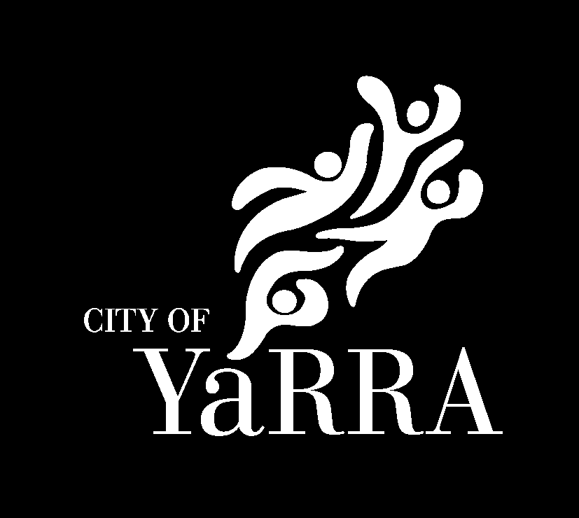

Yarra City Council acknowledges the Wurundjeri Woi Wurrung people as the Traditional Owners and true sovereigns of the land now known as Yarra. We also acknowledge the significant contributions made by other Aboriginal and Torres Strait Islander people to life in Yarra. We pay our respects to Elders from all nations and to their Elders past, present and future.

Yarra Moves – Physical Activity Action Plan

Introduction
An integral component of the Yarra Moves Strategy is the Action Plan. The Action Plan will be reviewed and updated every two years. This approach is necessary as the objectives of the strategy require long-term change that cannot be achieved via fixed perspectives, methods or systems.
Yarra Moves Action Plan prioritises short to mid-term initiatives that will contribute to the strategy’s long-term goals. Each version of the Action Plan will be reviewed and updated in line with agreed timeframes or as required. This process will enhance the plan’s relevance for the community and ensure resources are assigned in the most effective manner.

Yarra Moves action planning will:
- Address the 10-year strategic objectives to increase physical activity levels.
- Remain responsive to community needs.
- Be reviewed after the first year to inform the planning of the next two-year action plan (2024-2026).
- Set and integrate short, mid and long-term Council planning.

Action Plan 2022-2024 (July 2022 – June 2024)
The first iteration of Yarra Moves Action Plan is based on the immediate need to establish support structures and embed a culture of active living in all Council operations.
This Action Plan focuses on:
- Strengthening existing physical activity opportunities in Yarra.
- Creating a campaign to support the ongoing promotion of Yarra Moves and physical activity opportunities.
- Establishing a culture of active living at Yarra City Council.

The Yarra Moves Action Plan is created using the results from the community consultation in November and December 2021.

Achieving the strategic objectives requires input from a range of Yarra business units. This action plan maps out specific deliverables over the next two years across Council related to physical activity and active living.
The focus on physical activity and active living will continue to increase across Council throughout the 10 years of the strategy to achieve the vision of Yarra being synonymous with active living.

Throughout the Action Plan are the measurable outcomes, which will be reported on each year as part of the review of the plan. In addition to these measures, as outlined in the Yarra Moves Physical Activity Strategy, success will also be measured on improvements over time.
Contemporary industry data that informed the strategy and will be used as ongoing benchmarks of physical activity will include:
- Department of Health and Human Services’ Victorian Population Health Survey
- Sport Australia’s AusPlay Survey
- Victorian Health Promotion Foundation’s LGA Profile.
The impact on wider Council objectives will also be benchmarked against liveability indicators as reported in Yarra City Council’s:
- Annual Customer Satisfaction Survey
- Health and Wellbeing Status Reports.

Yarra Moves – Physical Activity Action Plan
Theme 1:
Impact and promotion
Empower the community to be physically active, supporting them to make choices through easy to understand information. Provide awareness of the varying ways you can be physically active and participate in the community.

Objective | Action | Responsible business units | Timeframe | Measurable outcomes | Resources
1.1 Identify and promote the opportunities to be physically active in Yarra. | 1.1.1 Build a Physical Activity Directory that showcases the physical activity opportunities available in Yarra. | Recreation | June 2023 | Physical Activity Directory available by June 2023. | Resources required.
 | 1.1.2 Establish a Yarra Moves communications program that promotes the importance of being physically active and reducing sedentary behaviour. | Recreation  Communications | December 2022 | Yarra Moves communication program launched by December 2022 and communications plan in place. | Resources required.
1.2 Promote opportunities for people to connect and participate in the community while improving physical wellbeing. | 1.2.1 Promote opportunities for volunteering and community participation across a range of activities e.g. environmental groups, sport groups etc. | Community Development (Capacity Building)  Recreation | Ongoing | Promote through social media, newsletter, or other volunteering/recreation networks a minimum of 6 volunteering opportunities that improve physical wellbeing each year. | Within current resources.
 | 1.2.2 Support Neighbourhood Houses and Learning Centres to continue to provide activities to the community focused on physical activity and wellbeing.  Promote the activities provided by Neighbourhood Houses and Learning Centres through the Physical Activity Directory. | Community Development (Neighbourhood Programs)  Recreation | Ongoing | Support each Neighbourhood House to provide a minimum of one program each year that focuses on physical activity e.g. yoga, pilates, tai chi, gardening workshop etc. | Within current resources.
1.3 Provide opportunities for the community to engage and connect with the natural environment to enhance their physical wellbeing. | 1.3.1 Facilitate access and promotion of spaces for people to engage in urban agriculture as outlined in the Urban Agriculture Strategy. Residents that can accommodate a planter box, productive tree or laneway garden are given the resources to apply for and keep the gardens healthy. Regularly run community growing spaces workshops, provide information to successfully gain a permit, be given a wicking system planter box (where appropriate) and the education to maintain their gardens to a healthy state eg. MySmartGarden workshops and information. | Urban Agriculture | Ongoing | Document the number of square metres of public land used in Yarra for growing food (includes Rushall, Condell and Railway community gardens, Burnley, Finbar and Balam Balam neighbourhood houses, planter boxes and laneway gardens). | Within current resources.
 | 1.3.2 Encourage and support nature focussed initiatives and engagement programs as outlined in the Nature Strategy. | Biodiversity | Ongoing | 250 households in the City of Yarra participating in a nature in the neighbourhood initiative by 30 June 2025 (Year 4 of Nature Strategy).  One streetscape initiative implemented by 30 June 2025 (Year 4 of Nature Strategy) that aims to introduce nature focussed elements into a neighbourhood, resulting in wellbeing and community benefits. | Within current resources.
1.4 Improving the health and wellbeing of all employees by implementing initiatives that make active living part of the workplace culture and reduce sedentary behaviour. | 1.4.1 Development of staff induction resources highlighting the importance of being physically active and less sedentary. E.g. speaker spot at induction and slides included in online induction. | Organisational Development  Recreation | December 2022 | Staff induction resources ready by December 2022 and included in each induction ongoing. | Within current resources.
 | 1.4.2 Include increasing active living and reducing sedentary behaviour as one of the monthly themes for the Wellbeing Action Group (WAG) each year. | Organisational Development  Wellbeing Action Group | Ongoing | Active living and reducing sedentary behaviour included as at least one monthly theme each year. | Within current resources.
 | 1.4.3 Promote opportunities to reduce sedentary behaviour in the workplace. | Recreation | Ongoing | 6 times a year provide information about ways to reduce sedentary behaviour in internal staff communications e.g. walking meetings, stand up desks etc. | Within current resources.
1.5 Use evidence to guide and drive decisions about how to increase participation in physical activity and improve the health of our community. | 1.5.1 Develop an evaluation framework that effectively monitors the impacts of the Yarra Moves Physical Activity Strategy. | Recreation  Social Strategy | June 2023 | Evaluation framework created by June 2023. | Within current resources.

Theme 2:
Inclusion
Provide a range of local options that cater to the diverse needs of different groups to support people to be physically active, particularly focusing on engaging those least likely to participate.

Objective | Action | Responsible business units | Timeframe | Measurable outcomes | Resources
2.1 Support and facilitate opportunities for the community to be physically active through Council’s services. | 2.1.1 Deliver and support a variety of programs to support active living and play for children and families in Yarra.  - First time parent groups, playgroups, integrated family services | Family Services | Ongoing | Yarra Council facilitates playgroups that provide active living and play opportunities throughout the year.  First time parent groups promote being active with baby and children.  Family Services promote and facilitate opportunities for children and young people to participate in physical activity programs and initiatives particularly focussed on more vulnerable families. | Within current resources.
 | 2.1.2 Deliver and support a variety of programs across Children’s Services to support active living and play for children in Yarra.  - Play-based activities and physical movement provided in all early childhood programs (long day care, occasional care, sessional kindergarten and out of school hours care).  - Playgrounds in centres resourced with equipment that invites and encourages children to move their bodies.  - Services provide regular community outings for children to learn and play in open space and nature.  - Specialist providers attend programs to provide bespoke movement experiences (dance, sport, yoga etc.).  - Out of School Hours Care and Vacation Care programs engage children in organised sports, organised games and informal play. | Children Services | Ongoing | As per quality improvement plans ensure play-based activities and physical movement are provided in all early childhood programs. | Within current resources.
 | 2.1.3 Deliver a variety of social sport programs for young people in Yarra.  - Weekly swimming program  - School holiday activities  - Support young people to participate in other sports programs and events  - Youth-led Grants  Advocate for more play and outdoor activity spaces with and on behalf of young people. | Youth Services | Ongoing | Deliver and/or support through partnerships a minimum of three weekly social sports programs for young people;  Ensure a minimum of two physical activities/excursions through each school holiday program;  Provide funding for at least two social sports programs, activities and events per annum through Council’s youth-led grants; and  Support young people’s advocacy for outdoor activity spaces (incl. key projects, such as the Richmond futsal pitch) | Within current resources.
 | 2.1.4 Support new and existing groups of older people to incorporate physical activity as part of their regular community group. | Aged and Disability Services  Recreation | Ongoing | Work with a minimum of two community groups of older adults each year to incorporate physical activity as part of their regular community group. | Within current resources.
 | 2.1.5 Deliver community-based programs to service vulnerable cohorts:  Aquatics - Women Making Waves and Access All Abilities.  Health and Fitness - Empower, Empower +, Move for Life and Collingwood Estate Gym. | Yarra Leisure | Ongoing | Women making waves: 3,000 visits annually  Access All Abilities: 10% of classes offered to be AAA classes  Empower: 20% Occupancy  Empower+: 20% Occupancy  Move For Life: 55% Occupancy  Collingwood Estate Gym (CEG): 20% Occupancy. | Within current resources.
2.2 Support active recreation and sport organisations to continue to provide diverse physical activity opportunities for the whole community. | 2.2.1 Deliver annual grant program's sport and recreation stream to increase community participation in physical activity. | Recreation  Community Development (Community Grants) | Ongoing | Under the participation initiatives stream have a minimum of 5 clubs apply for a grant each year to fund programs and projects that increase inclusion, diversity and access to opportunities that increase physical activity levels. | Within current resources.
 | 2.2.2 Provide support and club development opportunities to sport and recreation organisations and clubs in accordance with relevant strategic documents and in response to direct feedback from clubs through annual surveys. E.g. child safety, inclusion, diversity, strategic planning and governance. | Recreation | Ongoing | Deliver at least 3 development opportunities to clubs and organisations each year. | Within current resources.
2.3 Build partnerships with key partners to provide sustainable and inclusive local options to be physically active. | 2.3.1 Support health and community organisations to increase active living opportunities available to the community. E.g. Cohealth and North Richmond Community Health. | Recreation  Social Strategy | Ongoing | Meet with Cohealth and North Richmond Community Health a minimum of four times each year to identify and align objectives to increase active living opportunities. | Within current resources.
 | 2.3.2 Collaborate with peak sporting bodies and sport and recreation providers, supporting them to provide innovative ways the community can participate in physical activity. E.g. Disability Sport and Recreation, Reclink, Proud to Play and CMSport (Centre for Multicultural Sport). | Recreation | Ongoing | One initiative delivered in Yarra each year. | Within current resources.

Theme 3:
Active Neighbourhoods
The development of safe, accessible and well-connected neighbourhoods that optimise and encourage active transport and active living.

Objective | Action | Responsible business units | Timeframe | Measurable outcomes | Resources
3.1 Encourage and support greater walkability and cycling throughout Yarra. | 3.1.1 Develop and deliver the Yarra Transport Strategy (YTS) with a focus on safe and connected cycling and walking infrastructure networks. | Strategic Transport  Open Space Planning & Design  Traffic Engineering  Parking Management | Ongoing | Progress towards the targets as outlined in the Yarra Transport Strategy:  15km more compliant routes by 2027  25 cycling projects delivered by 2027  20% more cycling or scooter tripes by 2027  30 hoops each year and 1 bike corral per year | Resources required.
 | 3.1.2 Continue to address road safety issues and remove barriers to walking and cycling through Council’s Spot Safety program, Road Safety Studies and Road Safety Strategy. | Traffic Engineering | Ongoing | Deliver Local Area Place Making and Road Safety Study treatments included within 2022/23 budget;  Deliver any new Road Safety Studies included within 2022/23 budget;  Deliver roads safety treatments for which external funding has been provided in 2022/23;  Apply for external funding for road safety treatments for delivery during 2023/24. | Within current resources.
3.2 Plan and develop neighbourhoods to support active lifestyles. | 3.2.1 Continue to implement the Open Space Strategy. | Open Space Planning & Design | Ongoing | Delivery of the new Otter Street Park and Cambridge Street Reserve expansion.  Creation of the Linear Parklands masterplan. | Within current resources.
 | 3.2.2 Continue to implement the annual tree planting program through the Urban Forest Strategy. This program provides shade and encourages pedestrian activity and active transport. | Urban Design | Ongoing | The annual tree planting targets outlined in the Urban Forest Strategy be achieved. | Within current resources.

